# **Building Cultural Competence**

[Title]

Building Cultural Competence

[Competency]

Advocacy

[Estimated Time]

15

[Undraw Key]

Stepping Up



[Description]

Students are more apt to learn when they feel their cultural background is understood and valued. In this lesson, you will apply strategies for building cultural competence, or the ability to support and engage students of different cultures other than your own.

[Learning Objectives]

* Identify when students have different cultural backgrounds and experiences than your own.
* Practice strategies to build cultural competence, supporting and engaging students across cultures and backgrounds

[Text]

**Scenario 1**

Recently, Marcelo and his family moved to the United States from Mexico. Marcelo is a 6th grade student who is very quiet during tutoring sessions and often does not make eye contact with you. At times Marcelo forgets his notebook or comes late to the sessions. As his tutor, you want to help Marcelo excel as a learner.

[Image]



[[image link]](https://images.pexels.com/photos/4144095/pexels-photo-4144095.jpeg?auto=compress&cs=tinysrgb&w=1260&h=750&dpr=1)

Description: Teenage boy sitting at a table holding a calculator.

[Question - Open Ended]

1. What would you say to Marcelo to increase your understanding of his cultural background to best help him learn?

[Question - MCQ]

2. Which of the following approaches would help you best to increase your understanding of Marcelo’s cultural background?

I would say to the student:

1. “Marcelo, I understand that you want to do your own thing. I respect you as a learner and will give you space. Let’s move onto the next lesson.”
2. “Marcelo, I know you don’t talk much, so I reviewed your previous assessments and identified some problem areas that you need to work on. Let’s begin working on these problems first, as I really want you to do well!”
3. **“Marcelo, tell me about some differences between living in the U.S. and Mexico. What do you miss about Mexico?”**
4. “Marcelo, I think students from your cultural background are good in math and science. I anticipate you are going to do really well and will not need much tutoring.”

[Question - Open Ended]

3. Why do you think the approach you selected in question 2 will best support you to increase your understanding of Marcelo’s background as a learner?

[Question - MCQ]

4. Which of the following rationale aligns best with the approach you chose in question 2 above.

1. **When you ask a student about something that they notice and feel, you establish trust between you and them because it shows you respect and value their cultural background.**
2. As a tutor, when you go straight into teaching the lesson then the student knows that learning is more important and in particular, students should learn their cultural background does not matter.
3. When stereotypical assumptions are made about learners based on their cultural backgrounds, tutors can achieve a full understanding of them as individuals.
4. When students’ past assessments are considered more important than identifying their needs as a learner, students may continue to struggle and never reach their maximum potential.

[Text]

## **Research Recommendations**

Research suggests that educators can best improve student learning, when they understand student’s background. In addition, students are more apt to learn when they feel their cultural background is understood and valued. Therefore, the best approach to question 2 is:

**“Marcelo, tell me about some differences between living in the U.S. and Mexico. What do you miss about Mexico?”**

Research shows that in order to improve student learning, tutors need to understand students’ backgrounds and be comfortable working with students of all cultures and backgrounds. Cultural competence is defined as the ability to successfully understand and engage students who come from cultures other than our own. Building cultural competence is a process and does not mean learning a set of facts about specific populations. Developing cultural competence emphasizes a commitment to understanding the role of culture in shaping the way people view the world.

Four key cultural competencies, with adaptations to align with tutoring include:

1. **Awareness:** being aware of one’s own worldviews and internal biases. Tutors should practice awareness of their own opinions and views.
2. **Attitudes:** being open to differing views and opinions. Tutors should value the differing views and opinions of others.
3. **Knowledge:** knowing about differences in cultural practices and how these may impact students’ behaviors. Tutors should be open to learning about how culture shapes students’ perspectives.
4. **Skills:** developing and using strategies for effectively and respectfully communicating with students from different cultures. Tutors should apply skills of respectful communication with all students.

(Adapted from Cultural Competence Toolkit, 2023)

Research states cultural competence as the ability to recognize, engage, adapt and bridge across other cultures to create a more equitable learning environment. Developing cultural competence is an ongoing process that begins with increasing awareness about one’s own culture, values, and beliefs. This also involves willingness and ability to learn about other cultures. Tutors should strive to learn and recognize cultural backgrounds of their students.

[Question - Open Ended]

5. In your own words, why is it important to understand students’ background and develop skills to effectively communicate with all learners?

[Question - Likert]

6. How much do you agree or disagree with the expert belief that tutors need to practice cultural competence by striving to understand the role of students' background and culture to improve their tutoring?

1. Strongly disagree-1
2. Somewhat disagree-2
3. No opinion-3
4. Somewhat agree-4
5. Strongly agree-5

[Question - Open Ended]

7. Explain why you agree or disagree.

[Question - MCQ]

8. Which of the following statements do you agree with as the best reason for understanding students’ background and developing skills to effectively communicate with all learners?

1. When tutors understand students’ backgrounds, they make judgments about students’ learning capabilities and communicate the same to the learners.
2. **When tutors understand students’ backgrounds, they create a supportive learning environment that allows respectful communication and openness to different views and opinions.**
3. When tutors understand students’ backgrounds, they strengthen the stereotypical images of students based on their appearance and ask them to fit into the acceptable standards and their backgrounds do not matter.
4. When tutors understand students’ backgrounds, they can express openness to include many cultural perspectives, but they do not necessarily have to use this information to redefine their instruction.

[Text]

## **Research Recommendation**

Experts believe that the best rationale for understanding students’ backgrounds and developing skills to effectively communicate with all students is to strive to create a supportive learning environment. For this reason, the best response to the above question is:

**When tutors understand students’ backgrounds, they create a supportive learning environment that allows respectful communication and openness to different views and opinions.**

[Text]

**Scenario 2**

Recently, you began tutoring a student named Anka. Her family is Alaska Native, and she has been vocal about misrepresentations of her culture. For instance, upon meeting Anka for the first time, she corrected you on the mispronunciation of her name. As a learner, Anka likes to talk and is generally cheerful, but she withdraws when she feels ignored. As her tutor, you want to help Anka the best you can.

[Image]

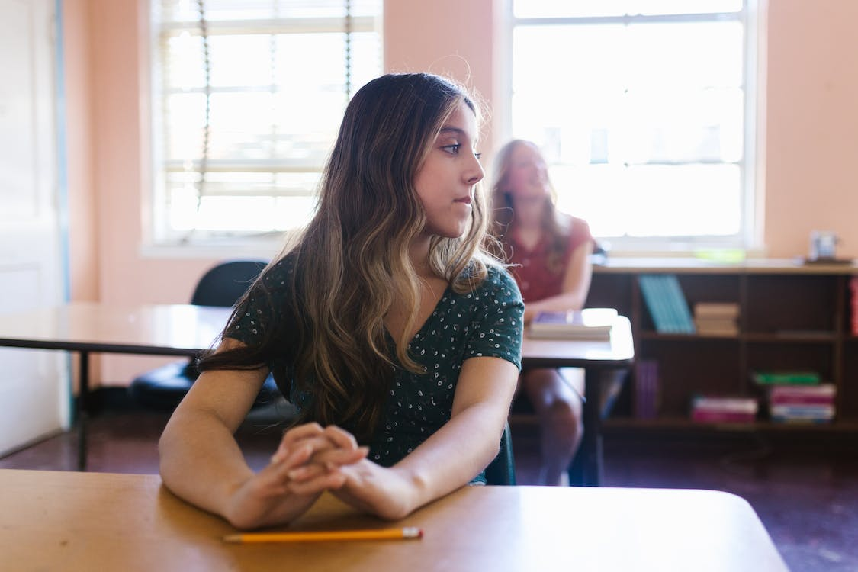

[[image link]](https://www.pexels.com/photo/a-girl-sitting-in-the-classroom-8419172/)

Description: Teenage girl sitting at a desk in a

[Question - Open Ended]

9. What would you say to Anka to increase your understanding of her cultural background to best help her learn?

[Question - MCQ]

10. Which of the following approaches would help you best to increase your understanding of Anka’s cultural background?

I would say to the student:

1. “Anka, thank you for calling attention to me mispronouncing your name. Now let’s get working on your math assignments together. It is important to me that you learn.”
2. **“Anka, I appreciate you telling me the correct way to say your name. Please tell me a little about yourself and your culture.”**
3. “Anka, I am not sure how much math instruction you have had in the past. So I reviewed your previous work and progress, and I identified topics we need to work on. I am excited to work with you!”
4. “I recognize you may feel different than other students, Anka. Please don’t think of yourself as culturally different from anyone else. You are just like all the other students.”

[Question - Open Ended]

11. Why do you think the approach you selected in question 10 will best support you to increase your understanding of Anka's background as a learner?

[Question - MCQ]

12. Which of the following rationale aligns with the approach you chose in question 10 above?

1. When you reassure a student that they are similar to all the other students, and you do not recognize them as being different, you are helping them feel like they fit in. It is important for students to feel they are part of the group.
2. It is important to acknowledge that students from different cultures may have varying past experiences in learning math. Tutors need to review student’s math performance to ensure they are providing support on the correct math topics.
3. **When you make clear attempts to gain knowledge about a student's cultural differences, such as asking about their culture, you are supporting students in culturally competent ways.**
4. Tutors should always stick to the topic of math and not ask students about their cultural background. Talking about culture and family can make students feel uncomfortable.

[Text]

## 

## **Conclusion**

Tutors should strive to gain knowledge of their student’s cultural background and practice strategies to understand how culture shapes student’s views and perspectives. Students are more apt to learn when they feel their cultural background is understood and valued. Therefore, the best approach to question 10 is:

**“Anka, I appreciate you telling me the correct way to say your name. Please tell me a little about yourself and your culture.”**

In summary, researchers define cultural competence as one of the essential skills in the fields of education, healthcare, and organizations. Building cultural competence requires effort and time because it involves learning to listen and to observe different cultures with an open mind. It also involves making an effort to gain knowledge and awareness of other cultures than your own. Practicing cultural competence is an ongoing process that helps tutors understand and engage students.

**Further Reading:**

For more information regarding how to build cultural competence, check out the resources below:

**References:**

Cultural Competence Toolkit (2023). Cultural Competence Toolkit. North Carolina State University Press. <https://diversity.ncsu.edu/cultural-competence-toolkit/>

Paris, D., & Alim, H. S. (Eds.). (2017). *Culturally sustaining pedagogies: Teaching and learning for justice in a changing world*. Teachers College Press.

Vilson, J. (2023). *Empowering Educators Through Cultural Competence.* Edutopia.

<https://www.edutopia.org/blog/empowering-educators-through-cultural-competence-jose-vilson>